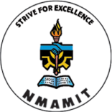**NMAM INSTITUTE OF TECHNOLOGY, NITTE**

***An Autonomous Institution under VTU, Belagavi***

***NATIONAL SERVICE SCHEME***

***Cordially invites you to***

**VITTIYA SAKSHARATA ABHIYAN (VISAKA)**

**Chief Guest:** **Dr. SRIKANTHA**

Professor,

Computer Science and Engineering, NMAMIT, Nitte

**Presided by: Dr. Niranjan N. Chiplunkar**

Principal, NMAMIT, Nitte

**Date and time: On Wednesday, 22nd February 2017 at 3.00 P.M.**

**Venue: Sowparnika Seminal Hall**

**N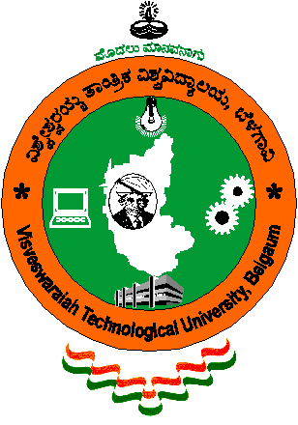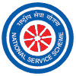OT ME BUT YOU**

**Dr. Janardhan Nayak**

**NSS Programme Officer Dr. Niranjan N. Chiplunkar**

**Principal**