

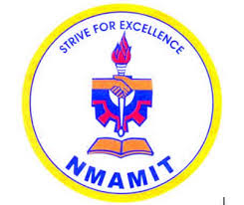

**N.M.A.M. INSTITUTE OF TECHNOLOGY**

(An Autonomous Institution under VTU, Belagavi)

Nitte- 574 110, Karkala Taluk, Udupi District, Karnataka

A Cordial invitation to the

**EXTENSION LECTURE**

**BY**

**Dr. Rathna G N**

**Principal Research Scientist, IISc, Bangalore**

**Time: 2.00 P.M.-4.00 P.M. Date:23rd February 2017**

**Dr. Rekha Bhandarkar Dr. Niranjan N. Chiplunkar**

Professor & Head Principal

TEACHING AND NON TEACHING FACULTY MEMBERS

**DEPARTMENT OF ELECTRONICS AND COMMUNICATION ENGINEERING**