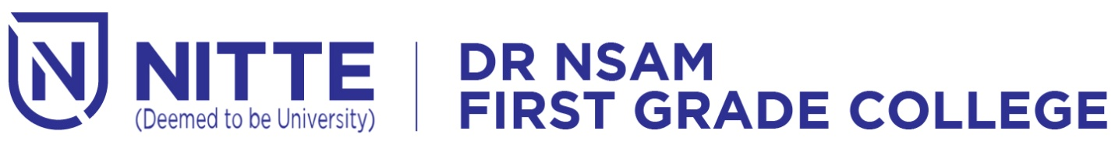

Nitte(DU) established under Section 3 of UGC Act 1956 | Accredited with ‘A+’ Grade by NAAC

**NIGMA 2024**

**State Level Fest**

***Date: 2nd and 3rd April 2024 Venue: Sambhrama Auditorium***