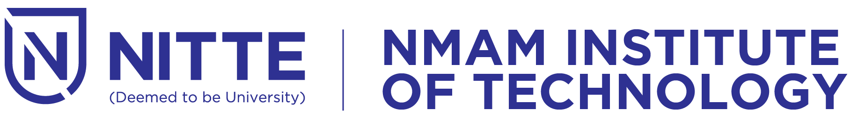

(An off-Campus Institution of NITTE (DEEMED TO BE UNIVERSITY), MANGALORE)

**DEPARTMENT OF MCA**

08/02/2024

From,

Dr. Mamatha Balipa

Professor & Head

Department of MCA

NMAMIT, Nitte.

To,

The Principal

NMAMIT

Nitte.

Dear Sir,

**Subject: Permission to organize Teck-KNO’ 24.**

The department of MCA is planning to conduct Teck-KNO’24, an intercollegiate technical competition for the Degree students of BCA, B.Sc. and B.Com on 29th February 2024. Dr. Mangala Shetty and Dr. Spoorthi B. Shetty will coordinate Teck-KNO’24. Hence, I request you to grant permission to conduct the same.

The estimated budget is enclosed herewith for your kind approval.

Kindly do the needful in this regard and oblige.

Thanking you

Yours sincerely

Dr. Mamatha Balipa

Professor & Head