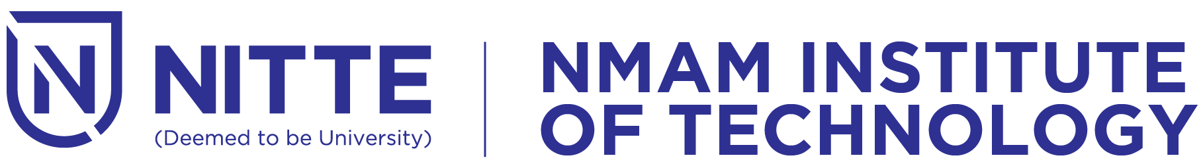
(An off-Campus Institution of NITTE (DEEMED TO BE UNIVERSITY), MANGALORE)
Department of MCA
24-11-2023
From,
Ms. Harshitha G.M
SAMCA Staff co-ordinator
Department of MCA
NMAMIT, Nitte.

To,
The Principal,
NMAMIT, Nitte.

Through,
Dr. Mamatha Balipa
Professor and Head
Department of MCA
NMAMIT, Nitte.

Respected Sir,

Subject : Permission for conducting farewell for final year MCA students

The department of MCA is planning to conduct farewell for final year MCA students on 15th December, 2023 in Sambhram auditorium at 9:30 a.m. I request you to grant us the permission.

Thanking you,
Yours sincerely

(Ms. Harshitha G.M)

