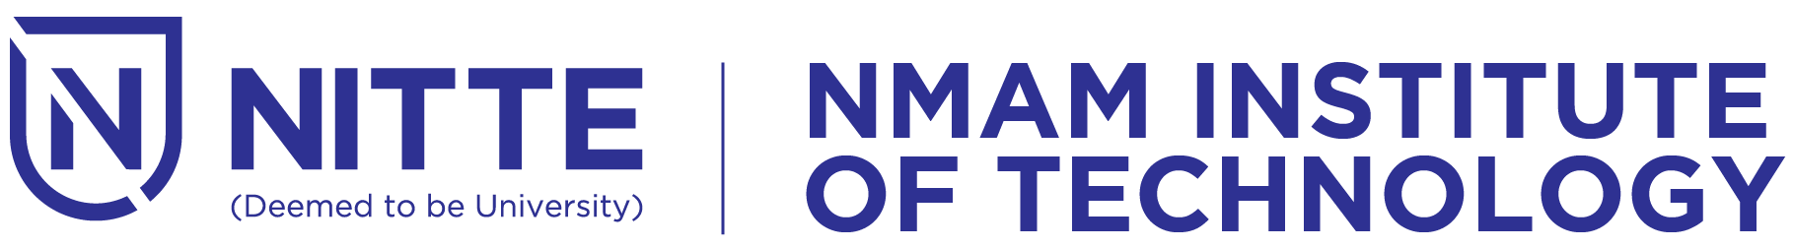

Off Campus Center of Nitte (DU)

**Department of MCA**

Faculty and Students

cordially invite you to the Event

***SAMCA Unplugged***

inaugurate the function

**Dr. Niranjan N. Chiplunkar**  
Principal, NMAM I.T., Nitte

will preside over the function

__________________________________________________

***Date : 14-11-2023 Time : 9.30 A.M.***

***Venue : SAMBHRAM Auditorium***

__________________________________________________

Dr. Mamatha Balipa Ms. Harshitha G. M.

Professor & Head  Staff Coordinator

Mr. Vyshakh Gowda J S Ms. Shravya

SAMCA President SAMCA Secretary

Book - Post



Off Campus Center of Nitte (DU)

**Department of MCA**

***SAMCA Unplugged***

on Thursday, 1st December, 2022

at 9.30 AM.

To : __________________________________

__________________________________

__________________________________

__________________________________