**About the Institute**

Nitte (Deemed to be University) has its roots in a group of Institutions established by the Nitte Education Trust. The Trust was established in 1979 by one of India’s respected Statesman, Late Justice KS Hegde, Supreme Court Judge and Speaker of Lok Sabha, with the mission of empowering rural youth through quality education and healthcare. The Trust has established 36 institutions spread in three campuses at Nitte, Mangalore and Bangalore. Following a review of Deemed-to-be Universities in 2012, MHRD, placed Nitte DU in Category A. Nitte DU received “A Grade” in its cycle 1 and “A+ Grade” in cycle 2 by NAAC with a CGPA score of 3.11 and 3.40, respectively. In 2017, UGC confirmed its continued recognition of Deemed to be University status. In 2023, it is placed65thin the Universities category of National Institutional Ranking Framework (NIRF), by MHRD, Govt. of India.The University currently offers 130 programs in disciplines related to health sciences, biological sciences, engineering, business administration, communication studies, and architecture.

N.M.A.M. Institute of Technology was established in 1986. The college is an Off-campus center ofNitte (Deemed to be University) and is recognized by the All-India Council for Technical Education (AICTE), New Delhi. It is accredited by National Assessment & Accreditation Council (NAAC) and all the eligible programs are accredited by National Board of Accreditation (NBA). It is placed in the band 101-150 in the NIRF 2023 ranking.

**About the Department**

The Department of Mechanical Engineering was started in 1986 with an intake of 40 students. Today the department has an intake of 120 students with a faculty strength of 40. The Department offers an undergraduate program, B.Tech in Mechanical Engineering and a PG program, M Tech in Machine Design. The Department is a recognized research center under Nitte (Deemed to be University). The faculty members are engaged in research activities with sponsored research projects worth more than Rs.1.2 Crores. The department has excellent research outputs in terms of publications, with a total number of 109 publications in the last three years.

One Day Workshop

on

on energy storage devices and e-waste management

***October 27th, 2023***

**Coordinators**

**Dr. Srinivasa Pai P**

Head, Dept. of Mechanical Engineering

**Dr. Santhosh G**

Assistant Professor, Dept. of Mechanical Engineering

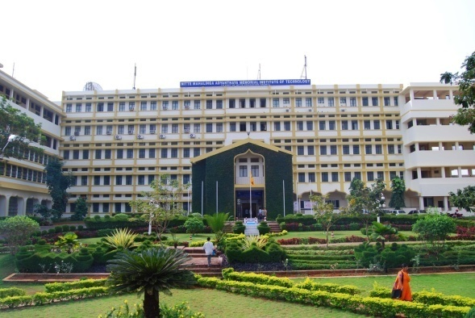

**ORGANIZED BY**

Department of Mechanical Engineering

NMAM Institute of Technology, Nitte - 574 110

Udupi District, Karnataka

**Participants**

**Category 1:** students pursuing their PG and PhD degree are eligible to apply.

**Category 2:** Interested faculty, post-doctoral fellow, research associates from institutions/ Research organizations/ Research labs/ Industry (both private and govt.) are eligible to apply.

**Resource Persons**

**Dr. Nayaka G P**

Dr. Nayaka G Pis working as a Scientist in the Dept. of Physical and Materials Chemistry, CSIR-National Chemical Laboratory, Pune, Maharashtra India. He obtained M.Sc. (2010) and Ph.D. (2017) in Industrial Chemistry from Kuvempu University. Later he moved to China as a Postdoctoral researcher (2017-2019) under a Chinese national Postdoctoral fellowship at Kunming University of Science and Technology, Kunming. He Joined CSIR-NCL as Scientist in 2019. His research is of multidisciplinary in nature comprising chemical, physical and engineering aspects of inorganic materials. He is working on Green Energy Materials for energy storage devices and e-Waste management to recover metal resources. He has published over 36 Int. Journal papers, 05 patents & amp;, 01 book chapter. He has received best paper award several times in national and international conferences. As of today, the Google Scholar citations are 1373 with h-index: 17 &amp; i-10 index: 19. He has reviewed number of manuscripts submitted to Int. Journals, evaluated Ph.D. thesis and Research project proposals. He has delivered invited talks on Energy storage aspects in many National seminars. He is an associate editor and editorial board member for 03 international Journals. He is the safety Co-ordinator of the Physical and Materials Chemistry and editor of Safety Hygiene Plane for CSIR-National Chemical Laboratory, Pune, Maharashtra India. Currently Two students are working with him for Ph.D, two for M.Tech dissertation. Apart from research, as a poet he Published a book of poems called Aahuthi.

**Dr. A. Aashish**

Dr. A. Aashish received his doctoral degree in Physical Sciences from CSIR-National Institute for Interdisciplinary Science and Technology (NIIST) in the year 2018. Post completion of his doctoral degree he did his post-doctoral studies in the Department of Physics, IIT Madras for a year. Later he worked as research fellow in SPEL, Pune, a supercapacitor manufacturer. His research interests include the development of hybrid composites as electrodes for various energy storage devices like supercapacitors, lithiumion batteries etc. Presently he is working as an Application Specialist at BioLogic (leading manufacturer of electrochemical workstations and battery cyclers). His nature of work is related to application support in the field of electrochemical applications.

**Registration fee:** Rs. 200 /-

**ACCOUNT DETAILS**

Account Name: Nitte Deemed to be University,

Account No.: 110047322915

Bank: Canara Bank, Branch: Nitte;

IFSC: CNRB0010115; MICR: 576015041

**Organizing Committee**

**Patron**

**Sri N. Vinaya Hegde**

President, Nitte Education Trust & Chancellor,

Nitte(DU)

## Advisory committee

**IMPORTANT DATES**

Last date for registration:**257hOctober 2023**

**CONTACT DETAILS**

**Dr. Santhosh G**

Assistant Professor, Mech. Dept.

NMAMIT, Nitte (DU)

Nitte- 574110, Karkala, Udupi District,Karnataka

Email:  [santhug099@nitte.edu.in](mailto:vijeeshv@nitte.edu.in) / 9611063163