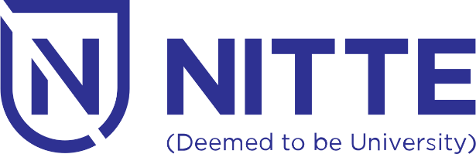

**NMAM INSTITUTE OF TECHNOLOGY**

**(Off Campus Center Institution of Nitte Deemed to be University)**

**INDUCTION PROGRAMME**

**for**

**B. Tech. Batch 2023**

**31 July - 16 August 2023**