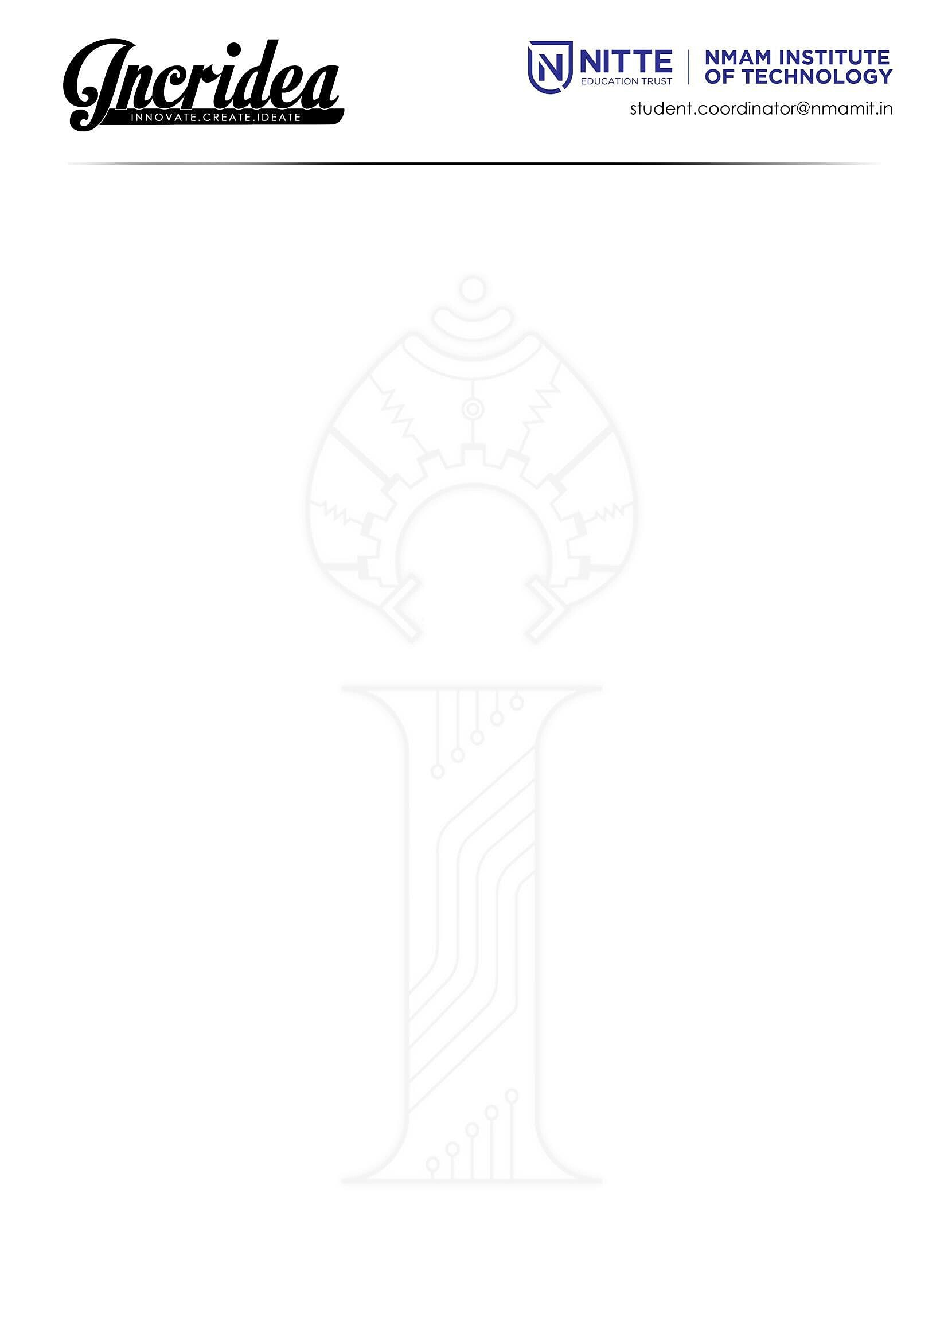

+91 9448815186

Dr. Niranjan N Chiplunkar

Principal

NMAMIT, Nitte

10th April 2023

Election Officer

Karkala, Udupi District

Respected Sir,

**Subject: Permission to organize a college fest at NMAMIT, Nitte**

I am writing to request your permission for our college, NMAM Institute of Technology, Nitte, to conduct our annual techno-cultural fest, Incridea, from the 26th of April to the 29th of April,2023 (9am - 9pm). We assure you that we will conduct the event with the utmost peacefulness and in strict accordance with the laws established by the honourable government.

We have taken all necessary measures to ensure that there will be no inconvenience caused to the public or any untoward incidents during the fest. Your support and permission for this event will be greatly appreciated.

Thank you.

Yours sincerely,

(Dr. Niranjan N Chiplunkar)