INCRIDEA-2023

Cultural Committee

Training for the selected students “Master of Ceremony” by Mr. Vaibhav D’Souza in connection with hosting INCRIDEA-2023.

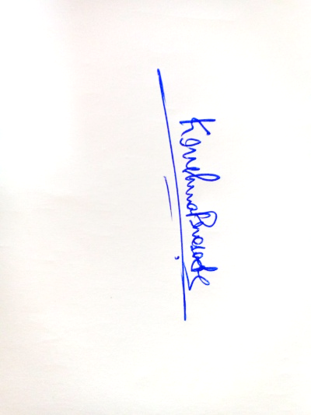

Dr. Krishna Prasad S

(Cultural committee Staff coordinator)