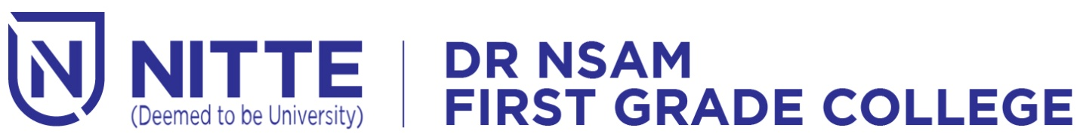

Nitte(DU) established under Section 3 of UGC Act 1956 | Accredited with ‘A+’ Grade by NAAC

**NIGMA STATE LEVEL FEST**

***Date: 3rd and 4th April 2023 Venue: Sadananda Auditorium***