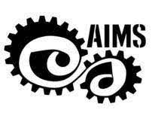

**DEPARTMENT OF MECHANICAL ENGINEERING**

**Lecturers Day 2022**

Date: 07 December 2022

Venue: Phalguni Hall, NMAMIT, Nitte

Timings: 1:45pm to 4:30pm

Report By: Shanald Olesh Furtado, Technical Committee, AIMS, NMAMIT, Nitte

After a long wait, AIMS will be organizing a Lecturer’s day, a half a day event at Phalguni Hall, NMAMIT, Nitte on 7th of December 2022. The event shall be restricted to Mechanical Department both teaching and non teaching staff, where they will be engaged in a series of fun activities and programs. Few AIMS volunteers will also be attending the session. The sole motive of this program is to give the much needed break to all the lecturers of mechanical Department and to give a fresh start to their duties further on.