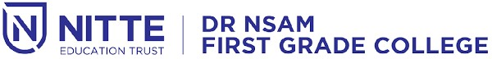

**NIGMA 2022**

**STATE LEVEL CULTURAL FEST**

**Date: 13th & 14th July 2022 Time: 10.00 a.m. Venue: Sambhrama Auditorium**

**ALL ARE WELCOME**