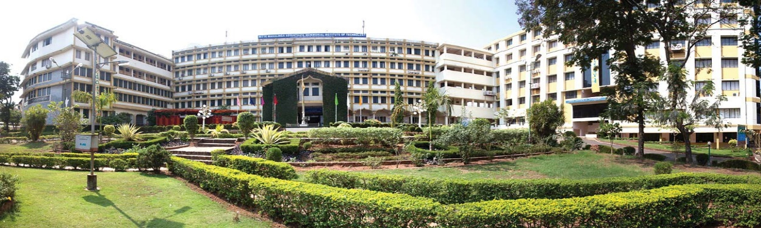

**Research Conclave 2022**

**Organized by**

**DEPARTMENT OF ELECTRICAL AND ELECTRONICS ENGINEERING**

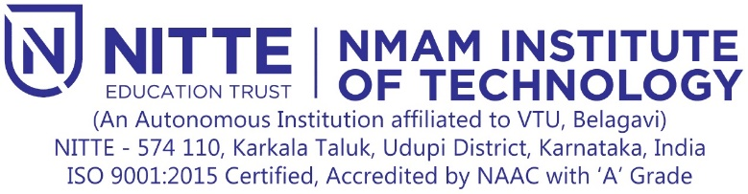

(An Autonomous Institution affiliated to VTU, Belagavi)

Nitte – 574 110, Karkala Taluk, Udupi District, Karnataka, India

ISO 9001:2015 Certified, Accredited by UGC NAAC with ‘A’ Grade

Phone: +91 8258 281264; Fax: +91 8258 281265

website: [www.nmamit.nitte.edu.in](http://www.nmamit.nitte.edu.in)

## About The Institute

Situated in the Sylvan surroundings at the foot of the western ghats, the Nitte village is 54 km from Mangaluru city. Nitte Mahalinga Adyanthaya Memorial Institute of Technology (NMAMIT), an Autonomous Institution affiliated to Visvesvaraya Technological University (VTU) Belagavi, is a premier Institute of Nitte Education Trust (NET). NMAM Institute of Technology was established in 1986. The institute is recognized by the All India Council for Technical Education, New Delhi, and accredited by National Assessment & Accreditation Council [NAAC] with an 'A' grade with a CGPA of 3.11. The institution offers 9 UG programs, among which Seven UG Programs i.e., BE in Biotechnology, Civil Engineering, Computer Science & Engineering, Electrical & Electronics Engineering, Electronics & Communication Engineering, Information Science & Engineering, and Mechanical Engineering are accredited by NBA, New Delhi under Tier - I category till 30th June 2021. UG programs on Artificial Intelligence & Machine Learning and Computer & Communication Engineering are started in the year 2020-21. The institution offers 8 PG programs. The institution has been granted Academic Autonomy under the Visvesvaraya Technological University from 2007-08 and certified to the ISO 9001:2015 standards for quality education by NVT Quality Certifications (ANAB accredited). The Institution has secured 133rd rank in the NIRF-2020 in the engineering category.

## About The Department

Department of Electrical & Electronics Engineering, established in the year 1987, offers UG and PG programs. The department has been offering M.Tech in Power Electronics (Autonomous under VTU) from the academic year 2014-15. The department is accredited by NBA for 3 years under Tier-I till June 2021. Equipped with the state-of-the-art laboratory in Power Electronics, Control Systems, Power Systems, and High Voltage & Relay, the department caters to the need of all Electrical & Electronics engineering students. “Center for Design of Power Electronics Systems” in the Research and Innovation Centre provides an opportunity to carry out advanced studies in the field of power electronics.

## About the Event

## This research conclave focuses all research scholars registered under Dept. of EEE, NMAMIT to present their work progress and accelerate their work by receiving the inputs from the subject experts. This conclave provides platform for the expansion of knowledge with latest developing pedagogy. The research scholars will gain the provision to enhance and upgrade the competency through exchange and sharing of knowledge in their chosen domain of study. This conclave acts as a catalyst to bring together all research scholars and exchange their views and experience.

**Event Date 18th February, 2022**

**Coordinator**

## Dr. Anitha Marina Colaco, Associate Prof, Dept. of E&E, NMAMIT, Nitte

## Contact Number: 7259149568, Email id: [anithamp81@nitte.edu.in](mailto:anithamp81@nitte.edu.in)