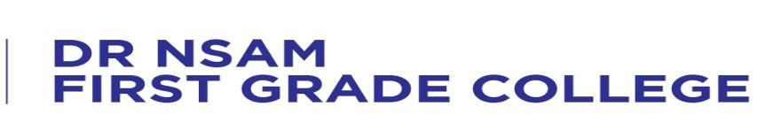
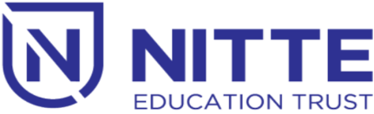

NET Campus, Nitte -574110 Karnataka, INDIA
(Re-accredited by NAAC with ‘A’ Grade)

AURORA – An Interclass Fest

will be held

4th February 2022 at 9.00 a.m.

Venue : Sadananda Auditorium

