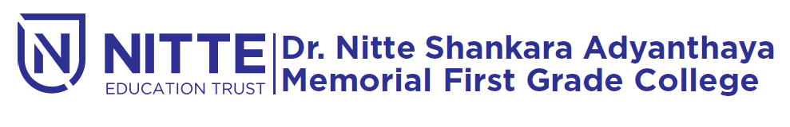

(Re-Accredited by NAAC with ‘A’ Grade)

Cordially invites you to the

NIGMA

**Dream Catcher**

**on 27th January 2020.**

**Time: 09.30 a.m to 7.00pm**

**Chief Guest:**

**Prof. sachin shetty**

***Principal, Staff and Students***