-

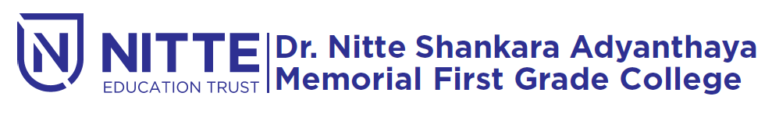
(Re-accredited by NAAC with ‘A’ Grade)

endowment lecture

will be held

on 20th February 2019 at 9.30 a.m.

Venue : SAMBHRAMA Auditorium

