-

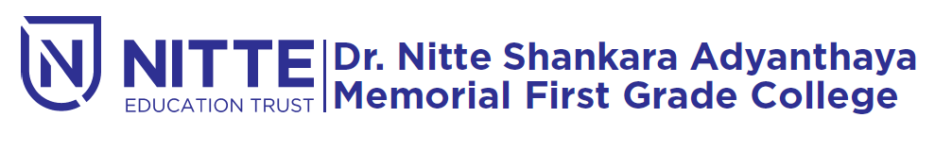
(Re-accredited by NAAC with ‘A’ Grade)

placement & training programme

will be held

on 16th December 2019 at 9.00 a.m.

Venue : SAMBHRAMA Auditorium

