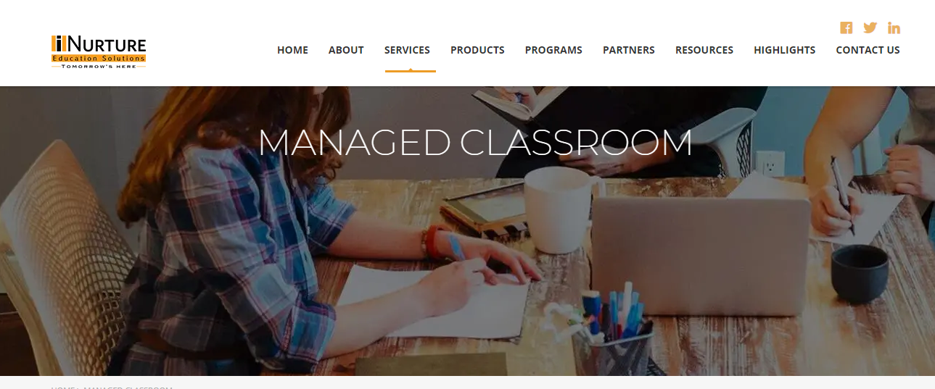

WEBINAR FOR MECHANICAL ENGINEERING STUDENTS

BY I NURTURE

SHAMBAVI SEMINAR HALL

24TH OCTOBER 2019 1-3PM