-

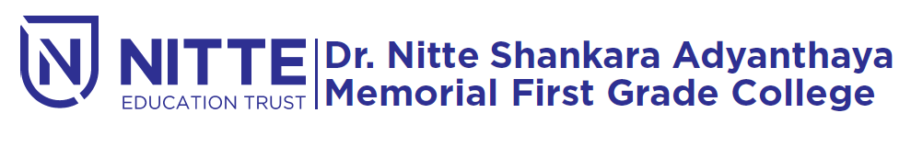
(Re-accredited by NAAC with ‘A’ Grade)

N-igma 2K20
STATE level fest

will be held

on 16th & 17th January 2020 at 9.00 a.m.

Venue : Sadananda Auditorium

