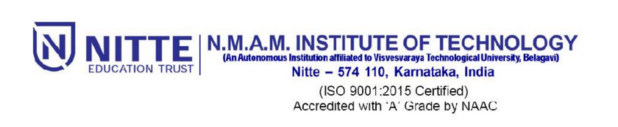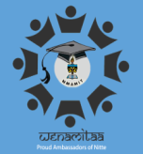

“WENAMITAA”

(NMAMIT Alumni Association)

Cordially invites you to share and celebrate this special day as one large family.

Global Alumni Meet

&

25Years of Graduation Celebration (1990-94 Batch)

On Friday, July 26, 2019 at Sambhram, NMAMIT Nitte.

Come and join us

* To renew friendships,
* Celebrate success in your chosen field of expertise, reminisce about days gone by and share your experiences

Dr. K Rajesh Shetty

Dean (Admissions & Alumni Affairs)

Dr. Surendra Shetty

President

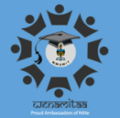**Programme Schedule - 26th July 2019**

Time: 9:30 AM- 4:30 PM

Venue: “Sambhram” Auditorium

1. Registration & Breakfast : 9:30 AM onwards
2. Visit to various facilities & Departments : 10 AM-11 AM
3. Inaugural Function : 11:30 AM to 12:30 PM

Inauguration by Sri N Vinay Hegde

1. Group Photo : 12:30 PM
2. AGM : 12:30 – 1:00 PM
3. Lunch : 1:00 PM- 2: 00 PM
4. Self introduction of Alumni & felicitation to Silver reunion batch : 2 PM – 3.30 PM
5. Entertainment programme - 3.30PM – 4.15PM
6. High Tea : 4:15 PM