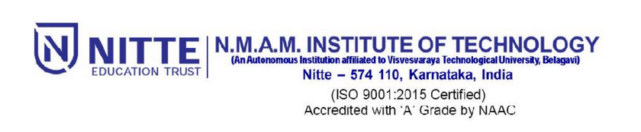

2019/NMAMIT/ Dean (R&D)/07 20/04/2019

**Circular**

There will be a talk on "**Smart Systems**" by  Dr.Vittal Prabhu of Penn State university and a Fulbright-Nehru fellow   at **11AM on 23rd  April 2019** in **Shambavi.**

The talk is Compulsory for all M. Tech. Students.

All faculty members are requested to attend.

**Principal**

Copy to,

Principal Table

Vice Principal (Dean - Academic), Vice Principal (COE)

Dean(R&D), Dean(Student Welfare), Dean(A&AA),

PG Coordinator

All HoD’s-with the request to make it mandatory for M. Tech. students to attend