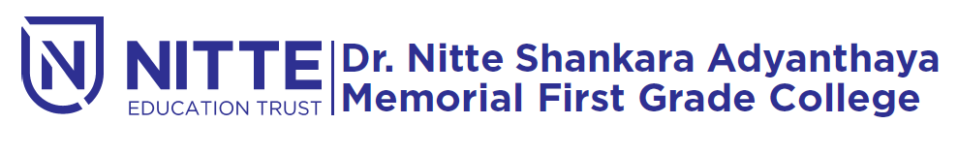
(Re-accredited by NAAC with ‘A’ Grade)

FAREWELL function

will be held

on 12th April 2019 at 9.00 a.m.

Venue : Sadananda Auditorium

