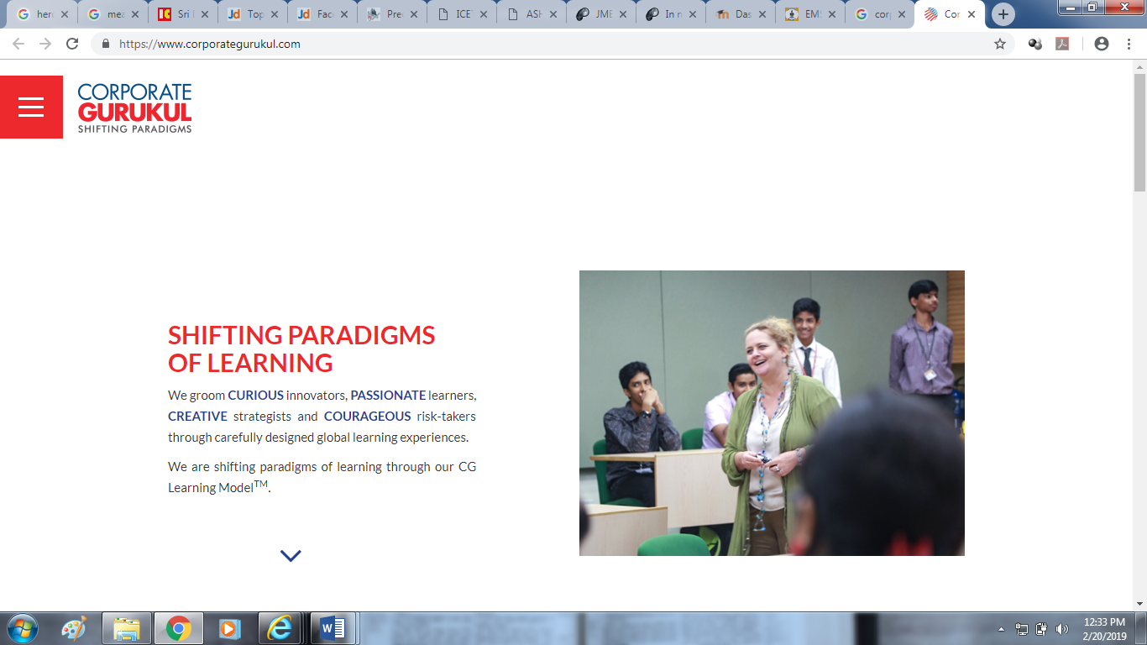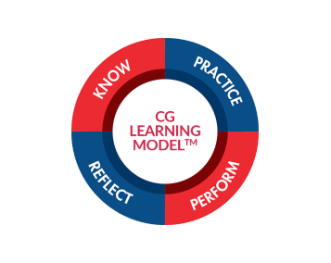

**Meeting of NMAMIT officials with corporate gurukul officials 25th the February 2019**