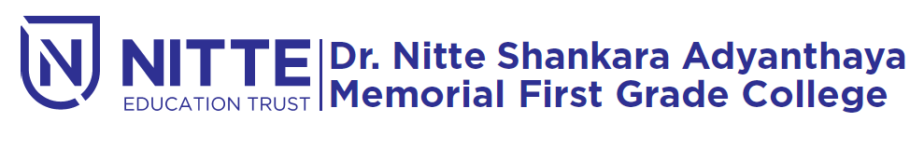
Re-accredited by NAAC with ‘A’ Grade)

Cordially invites you to the

Orientation program by

Ramakrishna Mission

On 25th February 2019.

Time: 09.00 a.m. `

Principal, NSS Officers and Students

