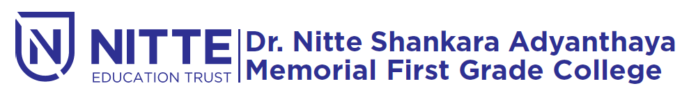
(Re-accredited by NAAC with ‘A’ Grade)

NIGMA 2019 QUIZ COMPETITION

will be held

on Tuesday 5th February 2019 at 9.00 a.m.

Venue : Sambhrama Auditorium

