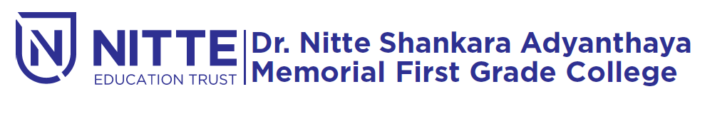
(Re-accredited by NAAC with ‘A’ Grade)

Kotak Mahindra Placement DRIVE

will be held

on Monday 21st January 2019 at 09.00 a.m.

Venue : Sambhrama Auditorium

