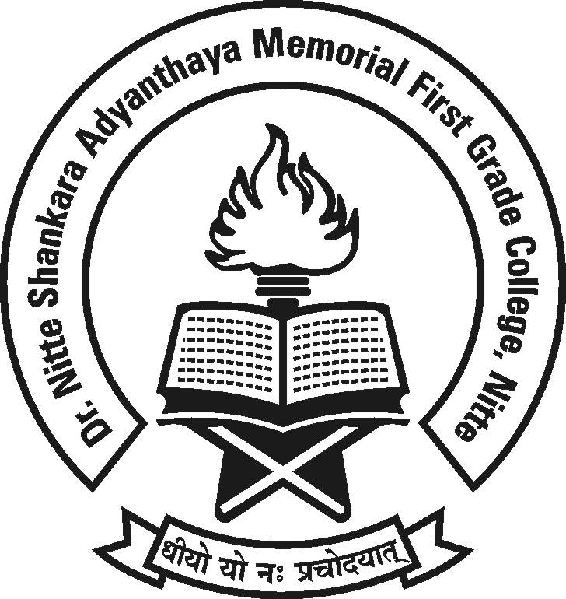

(Re-accredited by NAAC with ‘A’ Grade)

Cordially invites you to the
N-Igma-2K19

an

On 4th and 5th February 2019.

Inaugural Function Valedictory Function
Date: 04.02.2019 Date: 05.02.2019
Time: 10.00 a.m. Time: 3.30 p.m.

Chief Guest : Chief Guest :
Rtn.PHF. Abhinandan A Shetty Dr. Anasuya Rai
Dist. Governer Associate Professor &
Rotary International District 3182 Co-ordinator, Dept. of PG Studies in Commerce, University College, Mangalore.

Principal, Staff and Students

