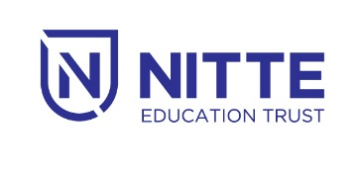

NITTE INSTITUTE OF BANKING & FINANCE

***TRAINING FOR SBI TRAINEES***

02.01.2019

3.00pm-5.00 pm

SAMBRAHM AUDITORIUM