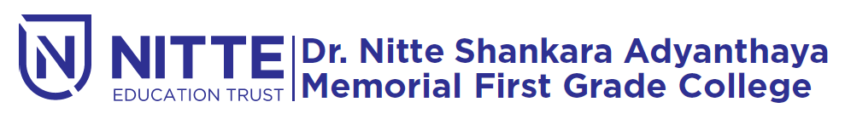
(Re-accredited by NAAC with ‘A’ Grade)

Campus Placement

will be held

on Wednesday, 19th December 2018 at 09.15 a.m.

Venue : Sambhrama Auditorium

