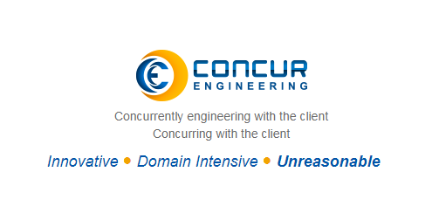

**Invited talk for Internship by Concur Engineering**

**27/10/2018 Time: 9:00am to 1:00pm**

**Venue: Shambhavi Hall NMAMIT Nitte**