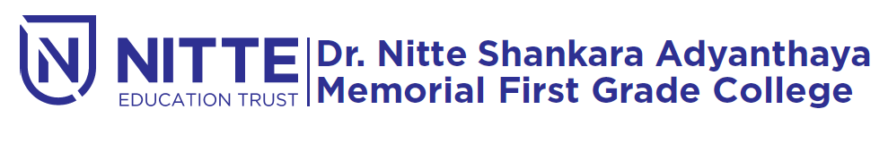
(Re-accredited by NAAC with ‘A’ Grade)

Modern marketing guest lecture

will be held

on Friday, 5th October 2018 at 12.15 P.m.

Venue : SHAMBHAVI Auditorium

