 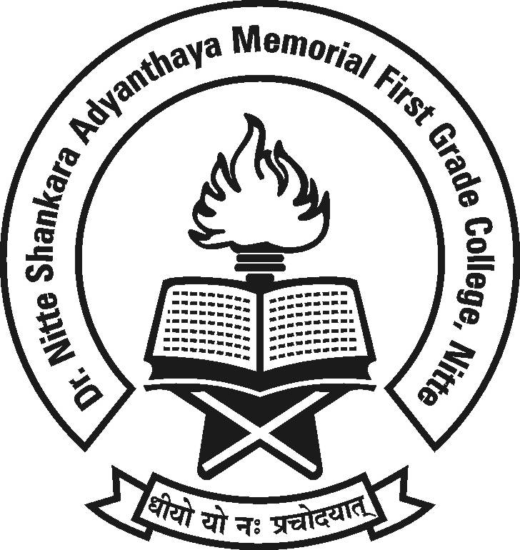

**Dr. NSA Memorial First Grade College, Nitte**

**“FAREWELL”**

**Date :05.04.2018 Time :2.00 p.m.**

**Venue : Sadananda.**

**All are cordially invited.**

**Management, Principal, Staff and Students**