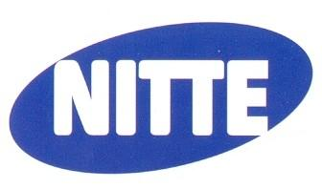 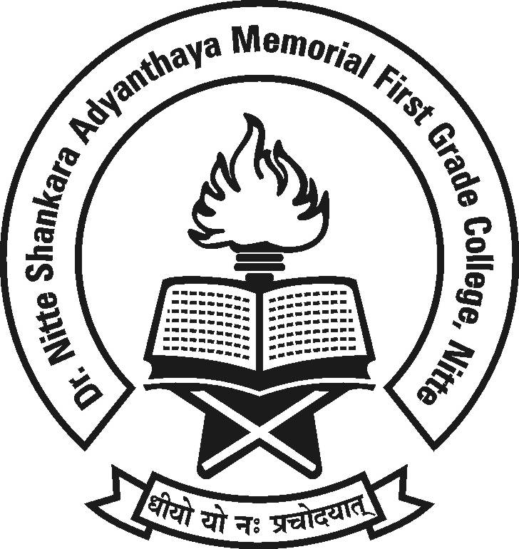

**Dr. NSA Memorial First Grade College, Nitte**

**“Legal Awareness Program”**

**DYSP, Karkala**

**will be the chief guest**

**Date :21.02.2018 Time : 02.00 p.m.**

**Venue : Sambhrama Auditorium.**

**All are cordially invited.**

**Management, Principal, Staff and Students**