NMAM INSTITUTE OF TECHNOLOGY,
NITTE

Dept. of Computer Science and Engineering

Cordially invites you
to the Inaugural function of
One year Audit Course on IOT
2017-18 &
Half day Workshop on
Internet of Things
By
Mr. Rajedra Bendre
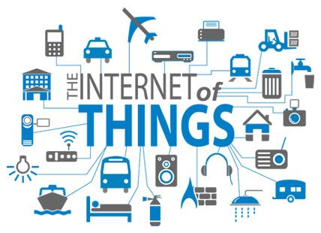
Chief Guest


Presided by

Dr. Niranjan N. Chiplunkar
Principal, NMAMIT
on 31th Aug. 2017 @ Time 9.00 AM
in Sowparnika

Dr. D.K.Sreekantha Dr. K.R.Uday Kumar Reddy
IOT Coordinator HOD, CSE

