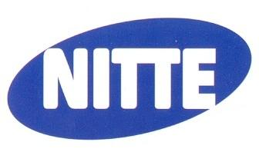 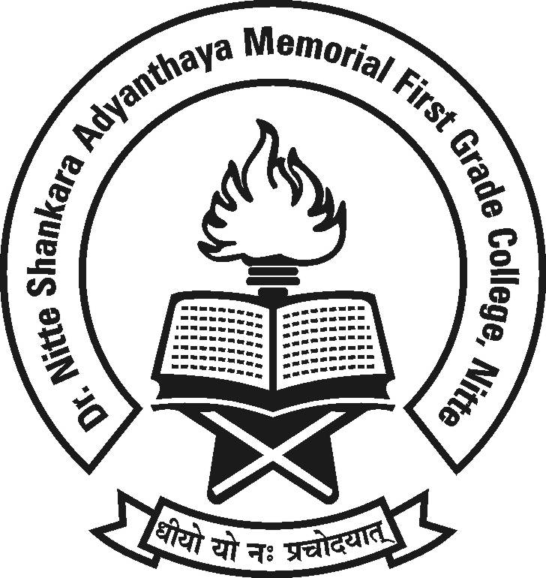

**Dr. NSA Memorial First Grade College, Nitte**

**NIGMA – 2K18**

A State level Inter-Collegiate Fest

**Date :8th & 9th Feb. 2018 Time : 9.00 a.m.**

**All are cordially invited.**

**Management, Principal, Staff and Students**