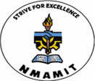
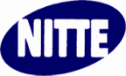
NMAM Institute of Technology, Nitte – 574110
Department of Information Science and Engineering

CIRCULAR
Date: 04/10/2017

ISTE Student chapter and VISTA are jointly organizing a technical talk on the topic “Recent Trends in Web Development for UI Developers” on 11th October 2017 at Sowparnika Seminar Hall from 1:30 PM onwards. Students are hereby informed to attend the same without fail.

Head- Dept. of ISE

