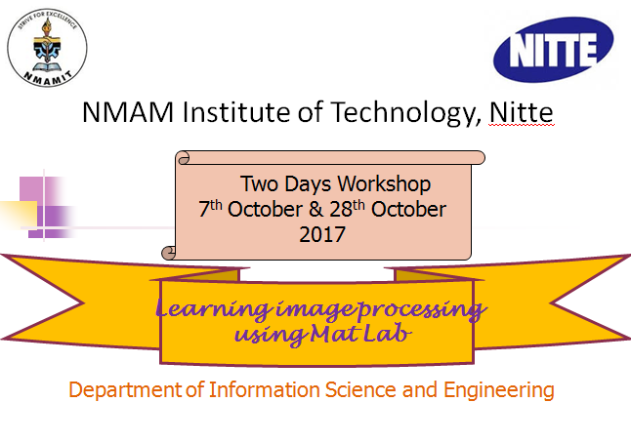

**Day-wise Schedule**

|  |  |  |  |  |  |
| --- | --- | --- | --- | --- | --- |
| **Day 1 (07th Oct. 2017)** | | | | | |
| 09:30 –10:10 | 10:10 -10:20 | 10:20 -12:00 | 12:00 -01:00 | 01:00 - 03:00 | 03:00-03:10 |
| Introduction to DIP | **T**  **e**  **a** | Hands-on session on mat lab | **L**  **u**  **n**  **c**  **h** | Segmentation in image processing | **T**  **e**  **a** |

|  |  |  |  |  |  |
| --- | --- | --- | --- | --- | --- |
| **Day 2 (28th Oct. 2017)** | | | | | |
| 09:30 –10:10 | 10:10 - 10:20 | 10:20 - 12:00 | 12:00 - 01:00 | 01:00 - 03:00 | 03:00-03:10 |
| Introduction to Image processing | **T**  **e**  **a** | Hands-on session on object detection | **L**  **u**  **n**  **c**  **h** | Hands-on session on video processing | **T**  **e**  **a** |