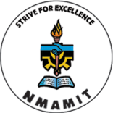
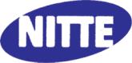
NMAM INSTITUTE OF TECHNOLOGY, NITTE

IEEE DAY & Guest Lecture
IEEE Members of M.Tech and B.E. students are attending the IEEE day & Guest Lecture by Dr. UC Niranjan, Director of Research & Training Manipal Dot Net Pvt Ltd, on 3rd October 2017 from 11am to 12 noon.

