 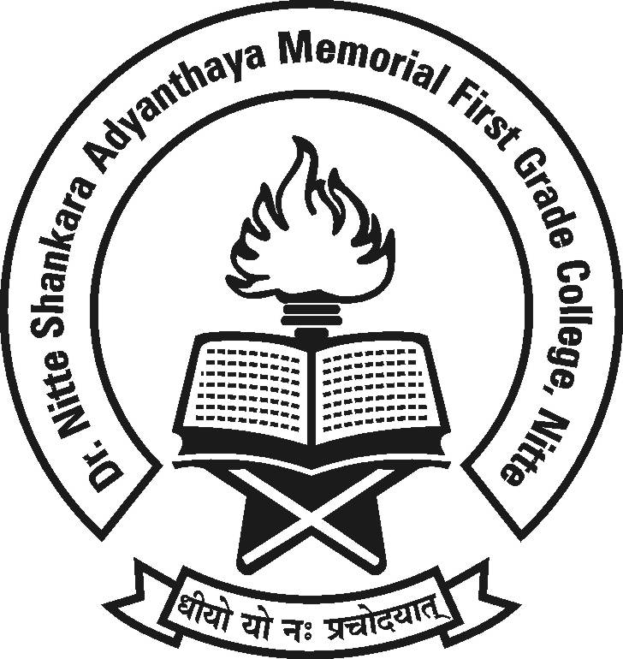

**Dr. NSA Memorial First Grade College, Nitte**

**Student Council Inauguration**

**Mr. Manjunath Kotian**

**Principal,  
 Sri Bhuvanendra College, karkala.**

**will be the Chief Guest**

**Date :11th July 2017 Time : 9.00 a.m.**

**Venue : Sadananda Auditorium.**

**All are cordially invited.**

**Management, Principal, Staff and Students**