 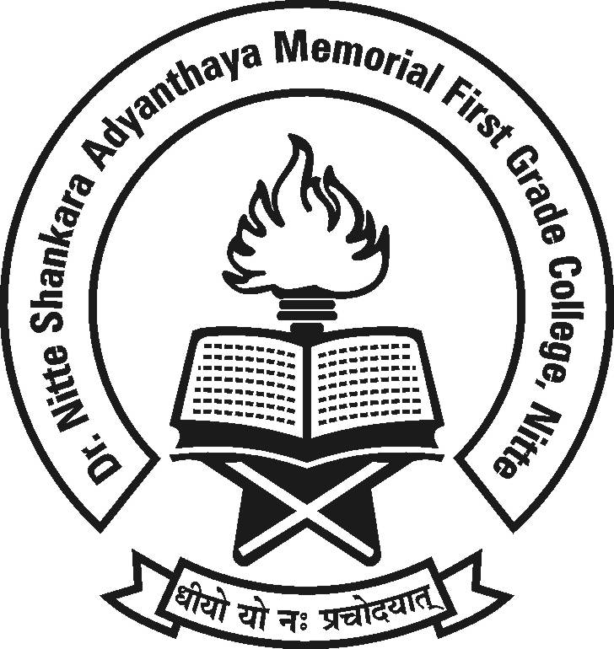

**Dr. NSA Memorial First Grade College, Nitte**

**FAREWELL**

**To**

**Final Year Students**

**Date :4th April 2017 Time : 12.00 a.m.**

**Venue : SadanandaAuditorium.**

**All are cordially invited.**

**Principal, Staff and Students**